# AI Fundamentals with DeepSeek (L1&L2) – Training – 3h

**Unlock the Power of AI Text and Reasoning Models for Your Business!**

## Course Description

**Course Description: 3 hours, 4 chapters, 2 practical exercises**

In just 3 hours, this dynamic training will transform how you engage with Generative AI. Through 5 focused chapters and 2 hands-on exercises, you’ll gain the skills and knowledge to harness DeepSeek’s cutting-edge capabilities. Whether you’re an individual or part of a corporate team, this course is designed to elevate your efficiency, creativity, and strategic thinking with AI.

## Why This Training?

* **Master the Essentials:** Build a strong foundation in Generative AI principles and applications.
* **Boost Productivity:** Learn to craft precise prompts that deliver high-quality results.
* **Drive Business Innovation:** Discover how to integrate AI into your operations for measurable impact.
* **Stay Ahead:** Gain insights into advanced techniques like Chain of Thought and how to use Reasoning Models.

## What You’ll Gain

1. **Deep Understanding of Generative AI Text Model:**
   * Explore the types, capabilities, and best practices of Generative AI tools.
   * Learn from real-world scenarios to identify effective use cases.
2. **The Art of Prompt:**
   * Master the ERCFC framework to craft powerful prompts.
   * Analyze positive and negative examples to refine your approach.
   * Practice with DeepSeek V3 to solidify your skills.
3. **Corporate Implementation Strategies:**
   * Understand how to integrate AI to enhance overall workflow efficiency.
   * Navigate risks and opportunities for enterprise-level AI adoption.
4. **Advanced Techniques:**
   * Learn how to implement Chain of Thought and leverage Reasoning Models for strategic analysis.
   * Explore DeepSeek R1’s unique capabilities and applications.
   * Apply your knowledge with practical exercises using DeepSeek V3 and R1.
5. **Real World Business Applications:**
   * Learn the capabilities of knowledge management to combine company valuable information with powerful Text AI Models.

## ***Who Should Attend?***

This course is perfect for professionals and organizations looking to:

* Improve efficiency and quality with Generative AI.
* Gain a competitive edge through AI-driven innovation.
* Equip their teams with the skills to implement AI solutions effectively.

## ***Outcome:***

By the end of this training, you’ll walk away with actionable skills, a clear understanding of AI’s potential, and the confidence to apply these tools in your business.

**Transform Your Approach to AI – Enroll Today!**  
Empower your team with the expertise to master Generative AI and drive meaningful results. Let System in Motion guide you on this transformative journey.

# AI Mastery (L3&L4) – Training – 3h

**Elevate Your AI Expertise to the Next Level!**

## Course Description:

This advanced 3-hour training is designed for professionals ready to take their Generative AI skills to new heights. Through 3 in-depth chapters and 4 hands-on exercises, you’ll explore cutting-edge techniques like MedPrompt, Reverse Prompting, and Tree-of-Thought to tackle complex, strategic AI challenges. Whether you’re an individual or part of a corporate team, this course will empower you to maximize the potential of AI tools and drive transformative results.

## Why This Training?

* **Master Advanced Techniques:** Learn sophisticated methods to enhance AI performance: MedPrompt, Reverse Prompting, Variables, Tree of Thought, and Prompt Chaining.
* **Optimize Corporate AI Integration:** Discover the 6 Pillars of Modern AI to ensure successful implementation.
* **Unlock Strategic Thinking:** Leverage Prompt Chaining and Tree-of-Thought for deeper, more impactful decision-making.
* **Gain Practical Expertise:** Apply your knowledge through 4 hands-on exercises designed for real-world application.

## What You’ll Gain:

1. **MedPrompt, Reverse Prompting, & Variables**
   * **MedPrompt:** Enhance the performance of generalist foundation models without specialized training or expert-curated content.
   * **Reverse Prompting:** Learn to work backward from the desired outcome to craft effective prompts.
   * **Variables:** Use variables to make your prompt generic so they cover more uses cases.
   * **Practices:** Solidify your skills with guided exercises.
2. **Corporate Implementation Strategies**
   * **The 6 Pillars of Modern AI:** Understand the critical factors for successful AI integration in your organization.
3. **Prompt Chaining & Tree-of-Thought**
   * **Prompt Chaining:** Master the art of creating a series of prompts to guide AI in generating precise, high-quality outputs.
   * **Tree-of-Thought:** Explore how Generative AI can support multiple thought processes for deeper analysis and decision-making.
   * **Practice:** Apply these techniques in real-world scenarios to refine your expertise.

## Who Should Attend?

This course is ideal for professionals and organizations who:

* Have completed AI Fundamentals Training or possess equivalent prompt engineering proficiency.
* Want to tackle more complex and strategic AI use cases.
* Aim to optimize AI tools for higher quality and efficiency.

## Outcome:

By the end of this training, you’ll have the advanced skills and strategic insights to:

* Enhance AI tool performance with sophisticated prompting techniques.
* Successfully integrate AI into your corporate workflows.
* Drive innovation and efficiency through advanced AI applications.

**Take Your AI Mastery to the Next Level – Enroll Today!**

Equip yourself with the expertise to lead in the AI-driven future. Let System in Motion guide you on this journey to mastery.

# "A Tale of Three Chinese AIs" – Keynote – 40-60 min

*Discover How China’s AI Innovations Can Transform Your Industry – Today!*

## Description

In just **60 minutes**, this **eye-opening keynote** will take you through three groundbreaking Chinese AI models—**DeepSeek, Manus, and Kling AI**—and reveal how they’re reshaping industries. Through **three focused chapters**,we explore real-world **use cases, unique strengths, and actionable insights** to help you understand the **AI transformation wave** and how to leverage it.

## Why Attend This Keynote?

✅ Master the unique capabilities of DeepSeek, Manus, and Kling AI—and what they mean for your business.

✅ Boost your understanding of AI agents, prompt engineering, and video generation consistency—critical skills for the future.

✅ Stay ahead by learning how China’s AI advancements can drive efficiency, creativity, and competitive advantage.

✅ Walk away motivated with a clear action plan to start integrating AI into your workflows.

## What You’ll Learn

### DeepSeek: Disrupting AI with Open Access & Affordability

What it is: A powerful open-weight LLM challenging proprietary models like GPT-4.

Why it matters: Discover how DeepSeek’s disruptive pricing & open-weight approach makes advanced AI accessible to businesses of all sizes.

Key takeaway: Learn how cost efficiency & transparency in AI can accelerate your adoption.

### Manus: The New Generation of AI Agents

What it is: An AI agent framework designed for autonomous task execution.

Why it matters: See how agents can streamline workflows, reduce costs, and improve scalability.

Key takeaway: Understand the specific approach to working with AI agents for business applications.

### Kling AI: Solving the Challenge of Consistency in Video Creation

What it is: A next-gen video generation AI producing highly coherent, dynamic content.

Why it matters: Explore how consistent AI-generated video can revolutionize marketing, training, and storytelling.

Key takeaway: Discover best practices for leveraging AI video tools in your creative pipeline.

## Who Should Attend?

🎯 Executives & Decision-Makers – Stay ahead of AI trends shaping your industry.

🎯 Knowledge Workers & Innovators – Learn how to integrate AI into daily workflows.

🎯 Tech & AI Enthusiasts – Get an inside look at China’s most advanced AI models.

## Outcome

By the end of this keynote, you’ll:

✔ Understand the unique strengths of DeepSeek, Manus, and Kling AI.

✔ Recognize real-world use cases and how they apply to your field.

✔ Leave inspired to take the next step in AI adoption.

**"Don’t Just Watch the AI Revolution—Lead It!**

# Company

System in Motion is a leader in the field of AI education and integration, committed to empowering established companies to seamlessly adopt AI technologies. Our offerings include comprehensive AI training, an AI Accelerator program tailored for existing businesses, and insightful keynotes that elucidate AI’s impact on industry practices. With a foundation built on quality, trust, clarity, leadership, and transformation, System in Motion provides a robust suite of services that prepare businesses for the future of AI. Our proven success stories and authoritative voice make us the preferred partner for companies aiming to innovate and lead in their respective industries. Join us to not only learn about AI but to master it and transform your business operations efficiently and effectively.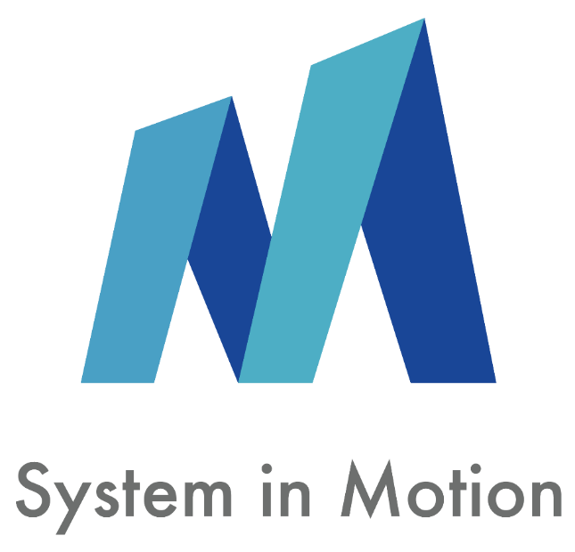

# Trainers/Speakers

|  |  |
| --- | --- |
| Guillaume Mallet  Sales and Partnerships Director  **System in Motion** | **Specialized in redefining backend systems for peak value**   * Completed engineering studies, specialized in information technology. Head of the Technology Function. * 18 years as an Account Manager at System In Motion, he has excelled in implementing technological transformation programs for Key Accounts, transforming information systems from cost centers into strategic execution tools. Prior to this, his role as a Project Manager saw the successful delivery of 20+ ERP projects, deeply transforming client core processes. * Over 1200 professionals trained in AI prompt practice in 2024. |